Assignment 3
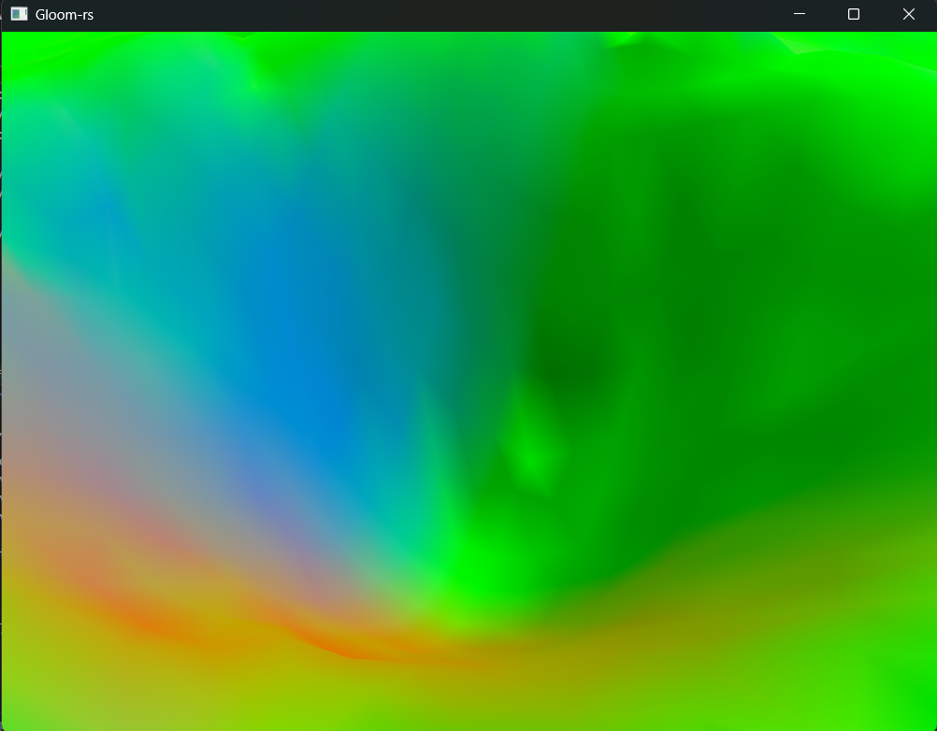
Task1
1c) Position your camera to point into one of the craters in the scene, and attach a screenshot of this immense natural beauty in your report.
On the right there is one of the craters in the scene (I’ll call it crater A) with my camera pointing towards it, it is seen from above such crater.
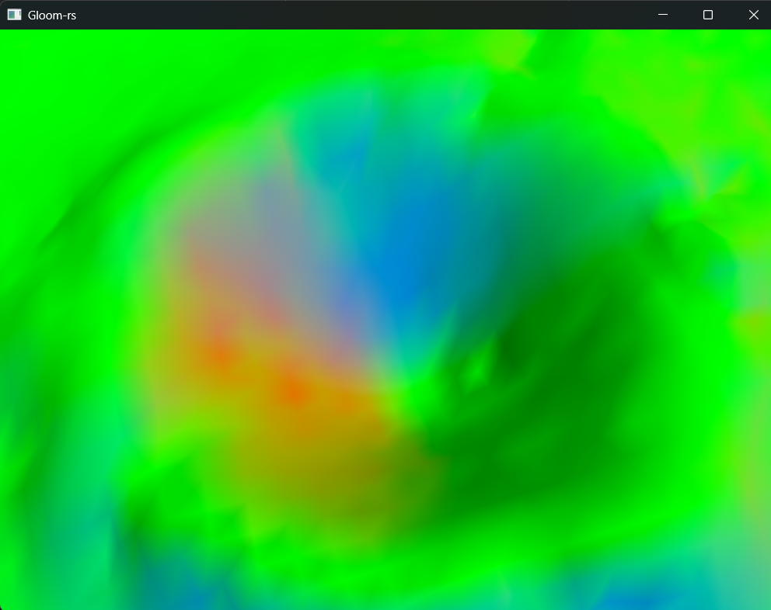
Below this text, the same crater (crater A) with the camera pointing towards it but from a higher altitude (still seen from the top of such crater).
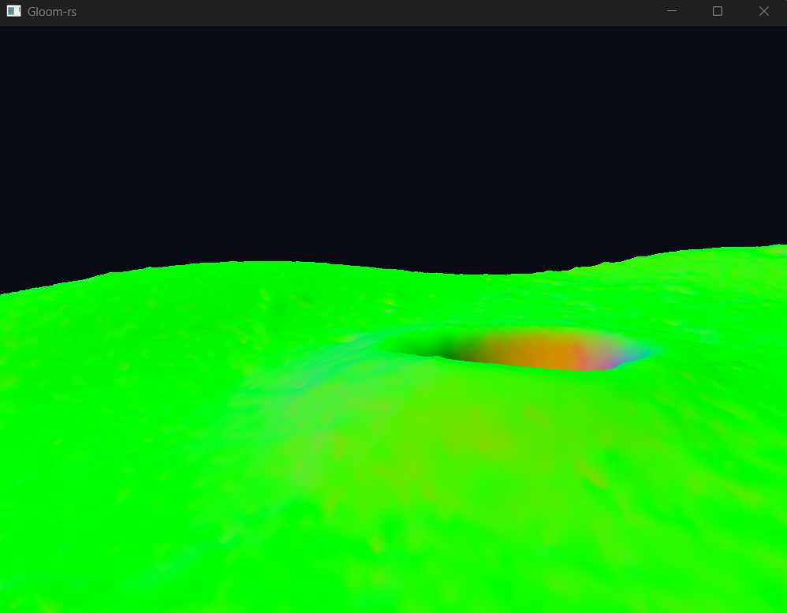
Below this text, there is a screenshot of another crater a bit farther away with the camera pointing towards it-
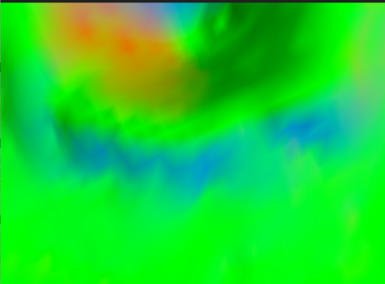
On the left and on the next page there are more screenshots of the previous crater (crater A):
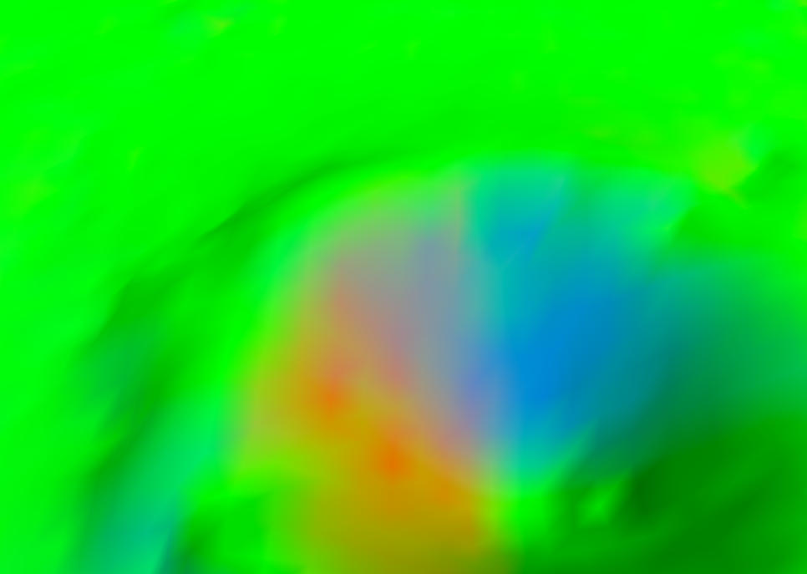
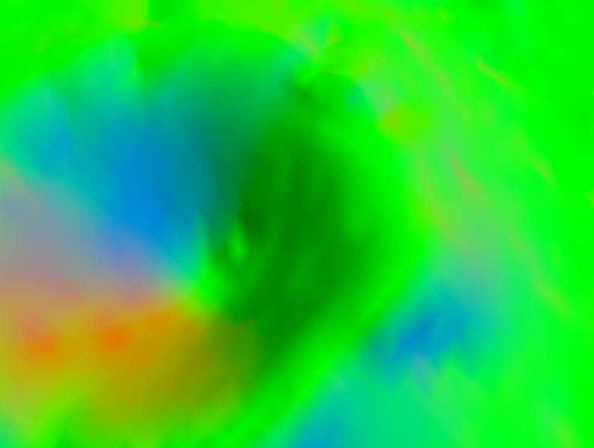
1d) The equation we want you to use to compute the final color in the fragment shader looks like this, when written with mathematical notation (Lambertian):
colorRGB ∗ max(0, v_{normal} ·−vlight _{direction})
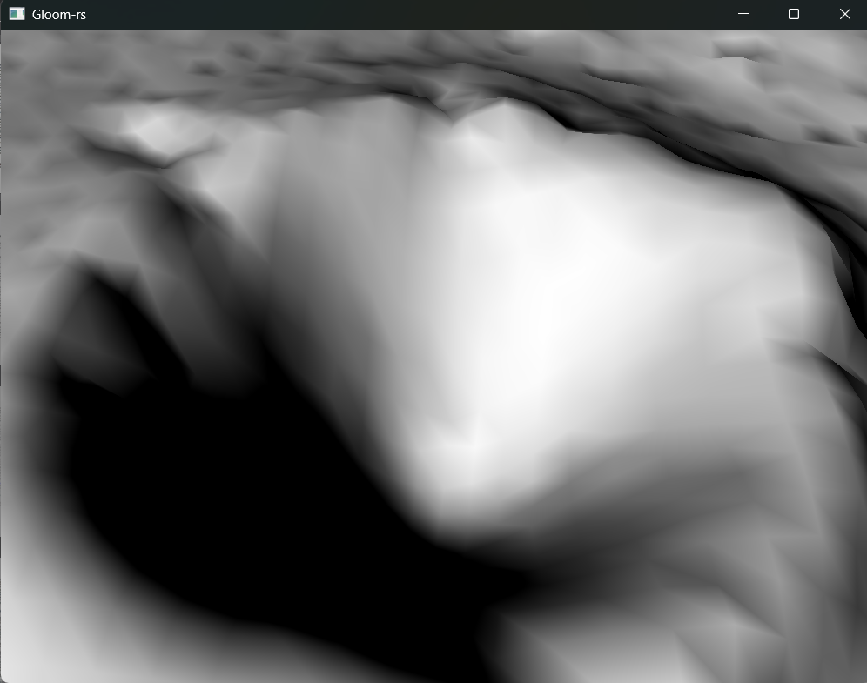
When you set the fragment color to this, all of the details in the lunar surface should become a lot more visible. Attach a screenshot which shows that the surface is correctly lit. (Note how the equation only applies to the RGB color components! Shadows should not cause the object to become transparent! Try modifying the gl::ClearColor to check for this).
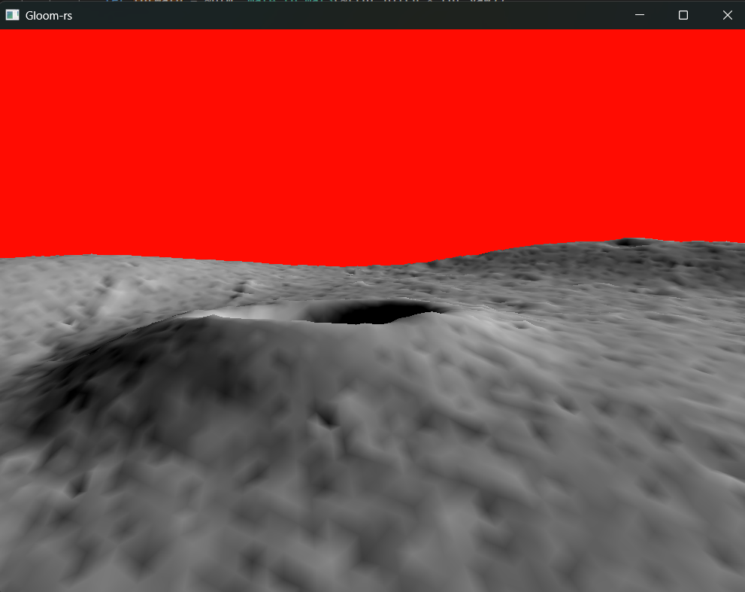
A surface that has a perfectly diffuse property is Lambertian. The radiant intensity reflected in any direction is proportional to the cosine of the angle of the normal to the surface. This is known as Lamberts Cosine law.
Here’s some screenshots with simple lighting implemented.
The sky is red because I modified the gl::ClearColor to check for transparency.

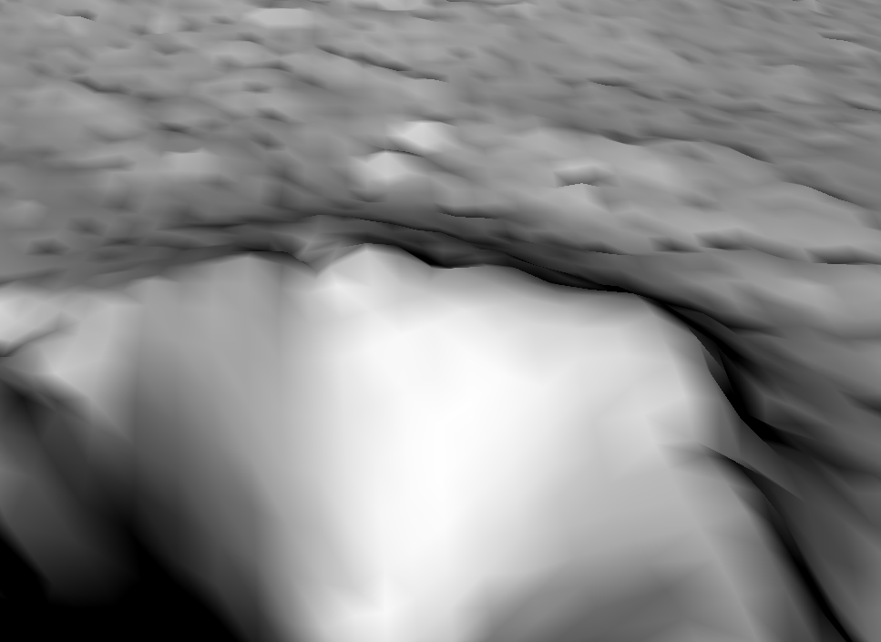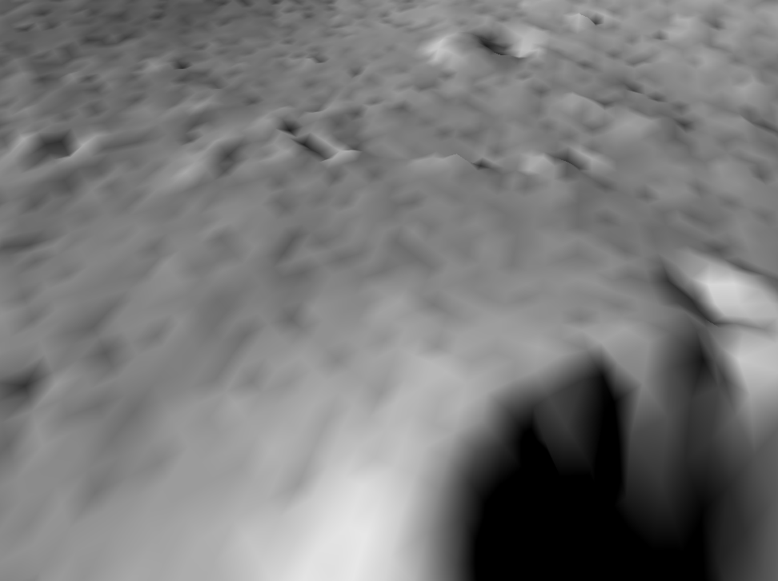

Task2
2c) Attach a screenshot showing the helicopter being drawn
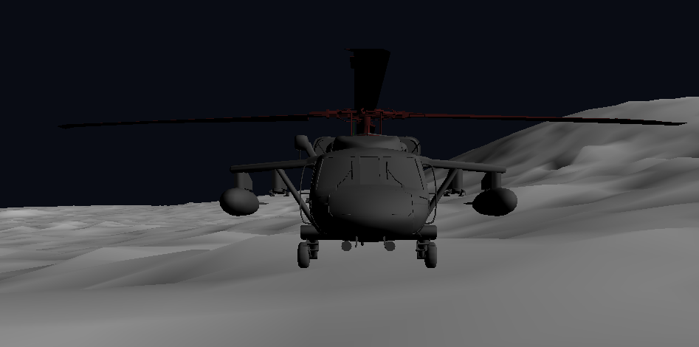
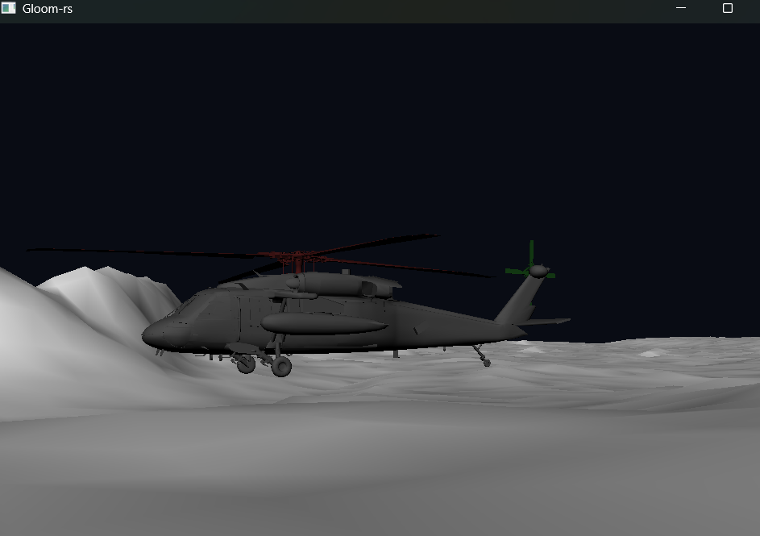
On the previous page and on the left, there are some images of the helicopter present in the scene in all its majesty.

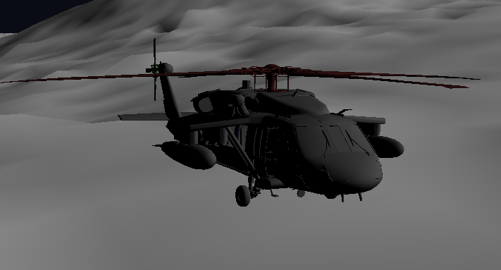

Task 5
5a) Attach two screenshots taken from the same camera position, one where we see the brightly lit side of the helicopter, and another taken when it has rotated and we see a darker side instead.
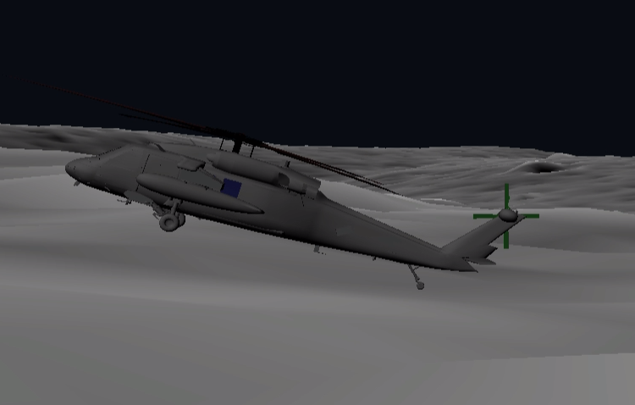 | In this example the brightly lit side of the helicopter is seen
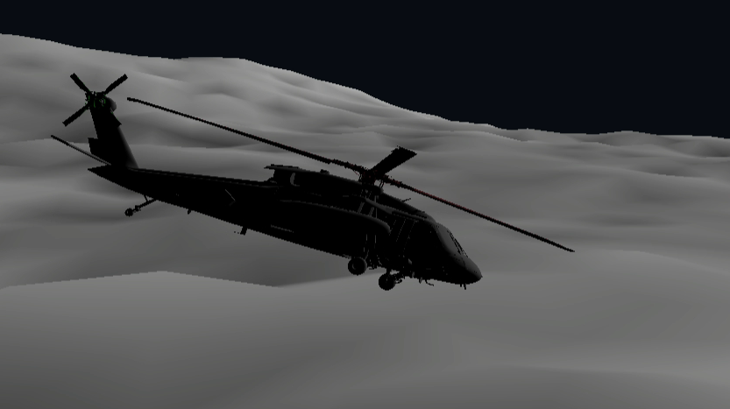 | In this example the dark side is seen

5c) Attach two new screenshots taken from the same camera position, where we see two sides of the helicopter
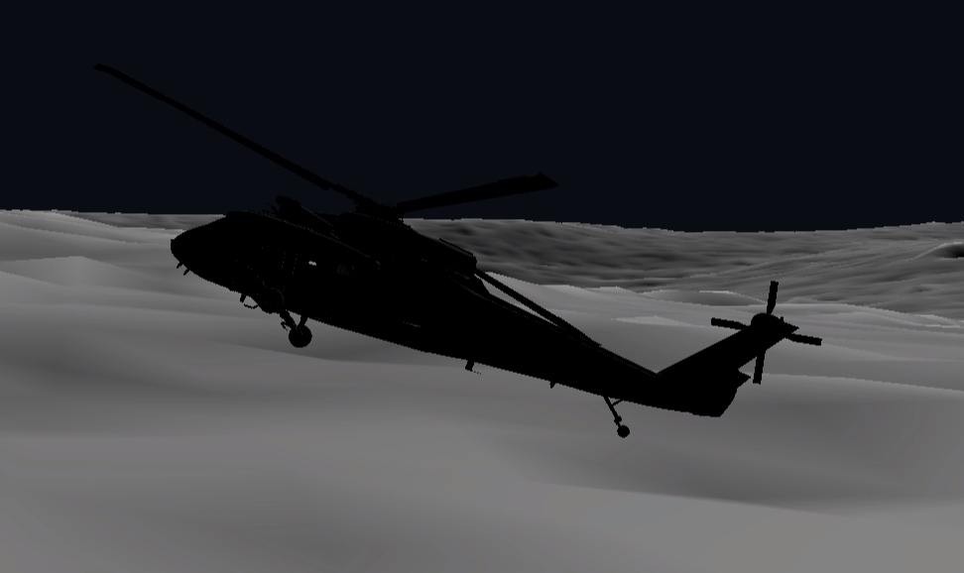 | In this example the camera position is not exactly the same of task 5a
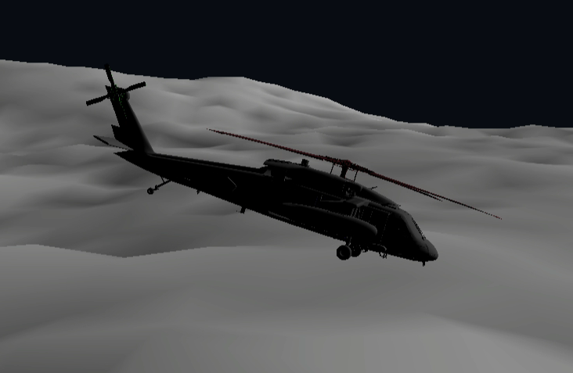 | In this example the camera position is not exactly the same of task 5a

Task 6
6a) Every one of the helicopters should follow the same path, but none of them should collide with any other. You can accomplish this by feeding the animation function a carefully selected offset. Attach a screenshot of the five helicopters.
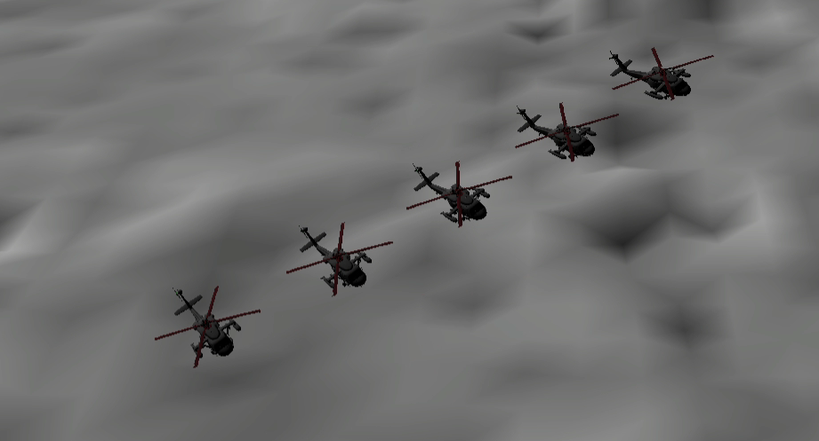
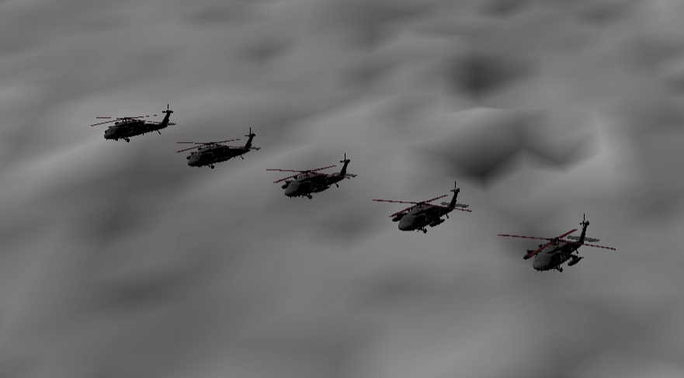

Task7 (optional)
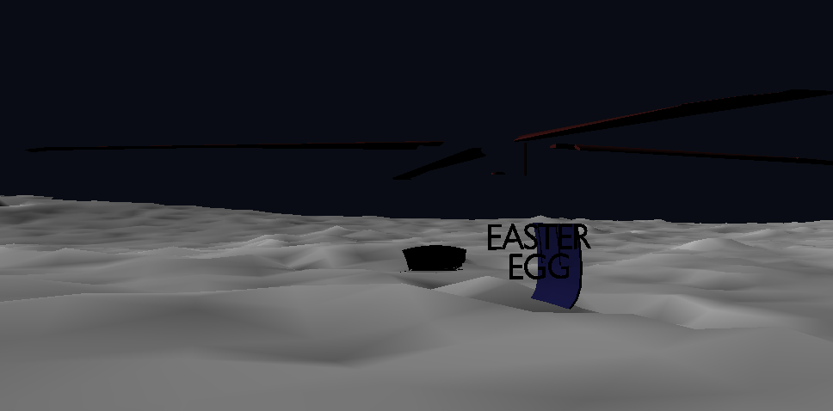
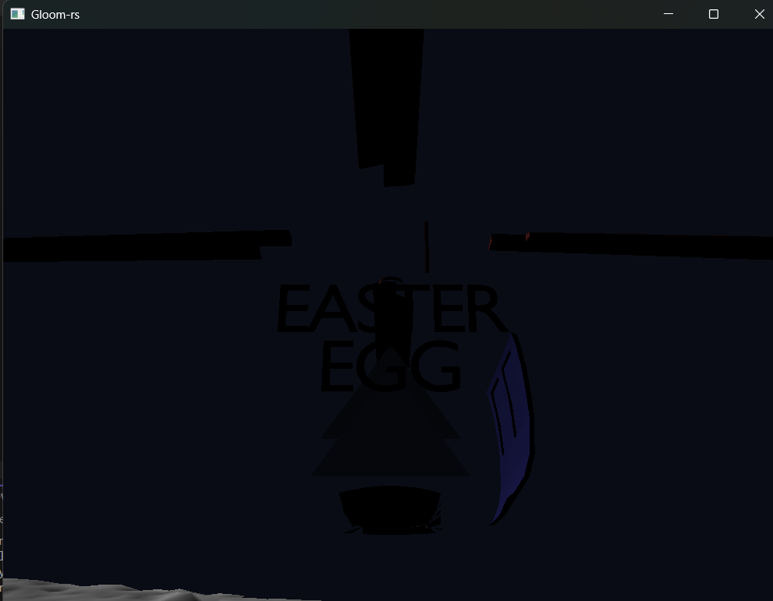
f) Easter egg found

